**REIQ Web Application Investigation**

DIGITAL SOLUTIONS IA2 ⏐ CAITLIN PETT ⏐ 2024 ⏐ YEAR 12

**Introduction**

**Purpose**

This investigation aims to present a comparison tool for the Real Estate Institute of Queensland. The tool will be in the form of a web application and will provide another way to compare property in Queensland, specifically using criteria such as distance from schools and public transport availability to help buyers find their perfect home. This investigation will look at potential user personas from the technical proposal, existing solutions, and requirements of the technical proposal to develop this tool. It will show the design process and the final proposed solution and evaluate it against self-determined and prescribed success criteria. Accompanying this investigation will be a document called ‘Annotated Code’ which contains all code used to develop the final solution, and a video called ‘Final Solution’ which demonstrates the functionality of the final solution.

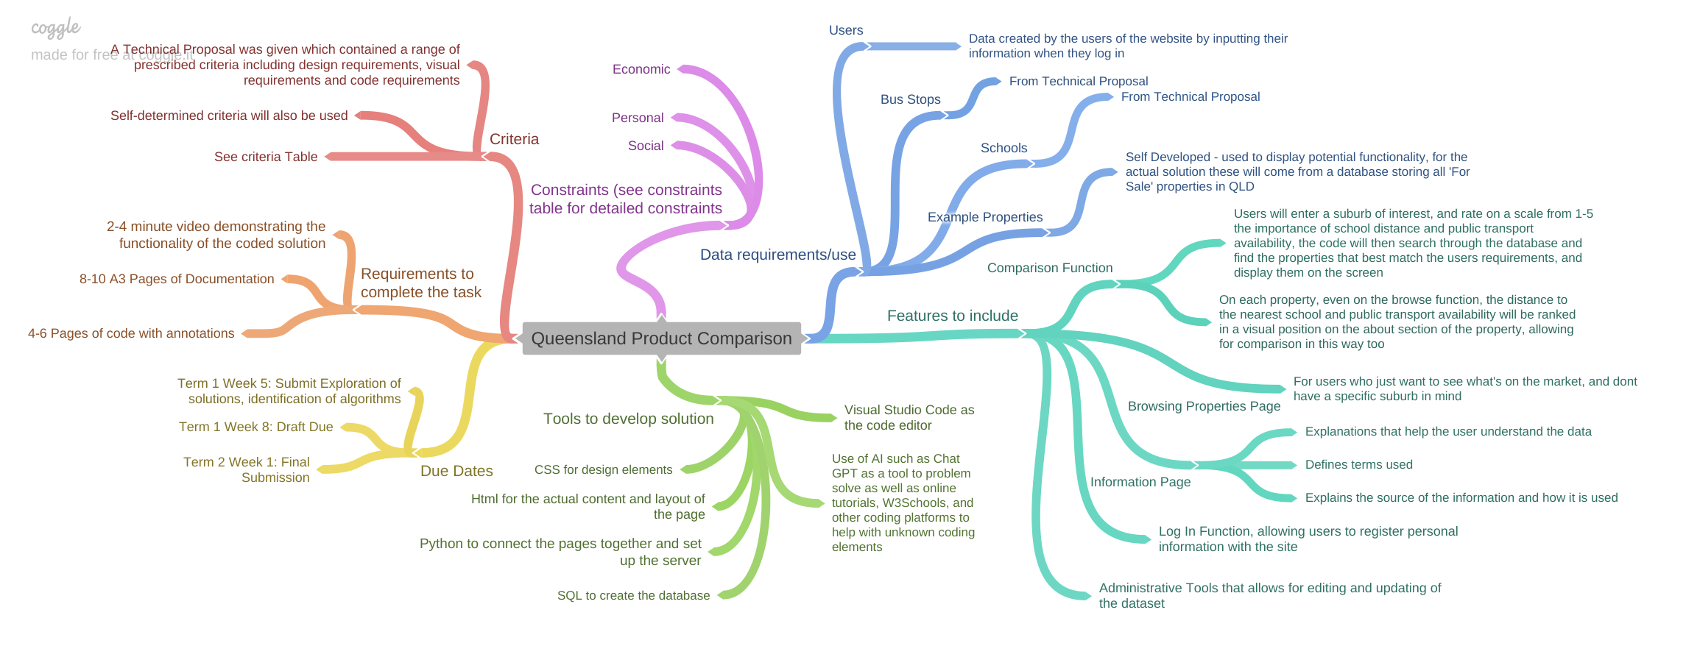**Deconstruction of the problem**

**Criteria**

The solution requires certain elements to be successful. These have been summarised into prescribed and self-determined criteria found below.

**Prescribed Criteria – Taken Directly from the Technical Proposal**

|  |  |  |
| --- | --- | --- |
| **Design Requirements** | **Visual Requirements** | **Coding Requirements** |
| * Allows exploration and comparison of the property market using school locations and transportation services criteria data. | * Provides an intuitive, responsive and dynamic web interface | * Read records from a csv file and store them in a database table |
| * Allow users to search for properties based on these criteria (schools and transportation) by entering a keyword | * Apply accessibility and usability principles | * Search the database based on specified criteria and display the results |
| * Contains an information page that provides appropriate explanations of the data, definitions of terms, the source of the data and how the data is used. | * Include appropriate attribution to data and images used | * Record and validate user registration details |
| * Provide an administrative tool that allows editing and updating of the database set – specifically allowing upload of the transport and school information to the website from a .csv file. | * Comply with copyright law | * Ensure the site is being operated by an authenticated user |
| * The web application complies with Government web design standards | * Utilise a “session” variable to manage the user’s “login” information |
| * Allow users to register the following personal details with the site: First name, last name, occupation and name of real estate agency/business | * The web application complies with the Australian Privacy Act (1988) | * An algorithm for checking the csv data before loading it into the database. |
|  | * Appropriate validation checks on new data before it can be uploaded to the database |
| * An incorrect user registration will not be stored in the database |

**Self-Determined Criteria**

|  |  |  |
| --- | --- | --- |
| Design Requirements | Visual Requirements | Coding Requirements |
| * Contains a browse function/page for users who want to see what is available to them, without having to search for a specific suburb | * Use the design principles of  balance, contrast, proximity, harmony, alignment, repetition and hierarchy to create a visually appealing website that ensures users enjoy using the web application and invites them to continue to use the service |  |
| * Addresses identified user needs using the potential user profiles. | * Use the REIQ colour pallet to ensure a cohesive blend between the two pages and to utilise the design principle of repetition |  |

**Constraints**

|  |  |  |  |  |
| --- | --- | --- | --- | --- |
| **Of the Task** | |  | **Of the Web Application (if it were to be developed into a functional website for the public to use)** | |
| Personal | * Time Limit – 10 weeks * Only able to use my personal computer and software that functions on it |  | Personal | * Certain skill levels will be required to code all aspects of the website |
| Social | * Working individually – nobody to collaborate with * While a database of bus stops and school locations has been provided, there isn’t a property database, meaning the properties used for this task may be fictional |  | Social | * Will need to use a realtor or another web application’s website of all available properties for the |
| Economic | * No monetary resources for this project |  | Economic | * Cost of hosting the web application * Infrastructure cost – will need a large amount of storage for all of the records - may already be in place as the records have to be stored somewhere * Development cost - payment of developers to physically create the web application |

**Existing Solutions**

Existing solutions have been investigated and evaluated against the usability principles to help identify the essential elements of a Real Estate User interface, and determine features to include in the REIQ web application.

1. **Property Value**

Property value is a site that’s main function is to help buyers explore potential properties through a search function, while also providing market tools to help users compare properties and suburbs.

|  |  |  |
| --- | --- | --- |
| **Usability Principle** | **Analysis** | **Ideas for Web Application** |
| Effectiveness | *Property Value’s* main purpose is to allow buyers to explore potential properties. This has been achieved as the home page contains a search function directly in the middle of the screen, that prompts users to search for addresses, streets, or suburbs. As users can easily access the website’s main function, effectiveness has been achieved. | The web application’s main purpose is to allow users to compare properties based on certain criteria (distance to schools & public transport availability), so using inspiration from Property Value, this feature could be located on the home screen, ensuring an effective design. |
| Utility | The website gives users all the tools they need to explore available properties. Looking specifically at the properties, the website displays their address, as well as important information such as the number of bedrooms, bathrooms, and garages, and displays photos. The image below shows how the properties are displayed when you first search, and then more information on the property appears once you select it to look at it.  The website also utilises a map, which gives users a visual on where the house is located helping them select their perfect property. | The web application will take inspiration from the way the properties are displayed, with the photo, address and other property information, while also including their distance to schools and public transport availability, potentially rated on a scale of 1-5, ensuring users have all the tools they need to compare properties in an area they are exploring. Adding a map would also improve utility, however it may be difficult at this stage, so it could be a potential future extension. |
| Safety | The Logo which takes you back to the home screen and the tabs which take you to other main pages stay at the top of every page, however they move slightly from where they are found on the home screen. Whilst this is still easy to understand how to get back to a particular page for most users, some may get a little confused.  There is also a navigation line at the top of the page when you are search for properties, that shows you where you are and where you are going, which also gives users the ability to go back to the map after clicking on a property. | For the web application the navigation bar at the top of the page which contains the logo and tabs to other main pages will stay in the same position for each page, making use of the design principle of repetition, and ensuring users aren’t confused.  Additionally, it could be a good idea to include a navigation line, showing users their journey through the web page like *Property Value* has implemented. |
| Accessibility | Most words are easily understandable due to their size, and the use of contrasting colours as backgrounds, compared to text colours. For example, the blue contrasts enough with the white for it to be readable. A recommendation for the website would be to enlarge the tabs across the top of the screen on the left to make them a little easier to read for users with visual impairments. | Ensure all words are a suitable size that is easy to read, even for users with visual impairments, and use contrasting colours for text and background.  Additionally, as mentioned in the prescribed criteria, use |
| Learnability | All features are clearly labelled, for example the search bar uses a search icon and written words to explain its function.    Additionally, the website explains the more technical terms they use to evaluate properties clearly and concisely, allowing for buyers to have a greater understanding of all the different aspects of each property. For example, it has pages explaining capital growth, cash flow, and lower risk, which are used to evaluate suburbs. | The web application will utilise a similar design for the search bar to ensure it is clear for users, while also providing a page that explains all technical terms. It will be more focussed on the data side of the web application, but will still help the users understand how the page works and what is done to find houses that exactly match their needs, to give them a better understanding when researching properties. |

1. **Property**

Property is another site that’s main function is to help buyers explore potential properties through a search function.

|  |  |  |
| --- | --- | --- |
| **Usability Principle** | **Analysis** | **Ideas for the Web Application** |
| Effectiveness | *Property’s* main purpose is to allow buyers to explore potential properties. Again, this has been achieved as the home page contains a search function directly in the middle of the screen, that prompts users to search for addresses, streets, or suburbs. As users can easily access the website’s main function, effectiveness has been achieved. | The web application’s main purpose is to allow users to compare properties based on certain criteria (distance to schools & public transport availability), so using inspiration from Property Value, this feature could be located on the home screen, ensuring an effective design. |
| Utility | The website gives users all the tools they need to explore available properties. As users go to search for a property, they are able to select the number of bedrooms & bathrooms, price, and the status of the property (e.g for sale, for rent ect.). This allows users to easily find a property that matches their exact needs.  This image shows the detailed and useful search function. | The web application will take inspiration from the features of the search function, prompting users to search for a suburb, and then rate the importance of distance to schools and public transport availability on a scale from 1-5, allowing them to find their perfect property. While being able to select their preferred amount of bedrooms and bathrooms would improve utility this may not be able to be achieved in the time frame and can be a future extension. |
| Safety | The Logo which takes you back to the home screen and the tabs which take you to other main pages stay at the top of every page, in the same position on every page.  Users are also able to adjust their filters once they have already searched, in case they make a mistake or change their mind. | If possible, in the timeframe, adding a function that allows users to adjust their preferences regarding the distance to schools and public transport availability would improve the safety in case users change their mind or make a mistake. This way they wouldn’t have to go back to the home page and search for everything again, which may become frustrating. |
| Accessibility | Most words are easily understandable due to their size, and the use of contrasting colours as backgrounds, compared to text colours. For example, the blue contrasts enough with the white for it to be readable.  To improve the accessibility (and also improve utility) a large map similar to the one found in Property Value could be implemented after users have searched, as this helps users visualise exactly where their property is found, compared to other properties in the area. While most listings have an ariel view in their selection of photos, this can take a whole to find after scrolling through their selection of photos. | Implement a map in the web design would make it more accessible to users, however this may be difficult as we do not have access to resources to create a map, and cannot use a system like google maps in the timeframe. |
| Learnability | Again the search bar is clearly labelled, shown below.    More buttons use icons to demonstrate their use, for example the ‘Location’ ‘Filter’ and ‘Price’ buttons, that allow you to adjust your preferences once you have searched. | Utilise icons alongside words to clearly communicate meaning, specifically with buttons. |

**Exploring User Personas**

User Personas have been analysed to determine their needs, as a self-determined criteria states that the solution should address users needs.

Additionally this table has helped determine essential features of the web application.

Solution

About the User

User Needs



* Looking for speed and accessibility
* Ability to see proximity to schools and bus stops
* Same feature for buses
* E.g. 200m, 500m 1km ect
* Users select the ir preferred proximity to a school when searching
* Property cards display the schools nearby
* Search feature on the first page after the ‘sign in’ for accessibility
* Be able to identify properties good for families
* Predominantly deals with families
* Experienced real estate agent

* This will expand his knowledge of the Brisbane Market
* Browse feature shows all available Brisbane properties
* Expand his knowledge of Brisbane Clients
* Expand his knowledge of the Brisbane market
* Only been working professionally for 6 months
* Young real estate agent



* Successful salesman looking to buy property
* Has children
* Has a wife who works from home
* Search feature allows users to select their preferred distance to a school in a suburb
* Needs to know the number of bedrooms
* Wants space for his children, his wife’s business and mother-in-law
* Potential extension ideas with information about traffic and parks
* This accommodates for his children
* All property cards will show the number of bedrooms within the house
* Wants to be close to a park
* Ability to identify a property good for his family

**User interface and design**

**Wireframes**

The following images and descriptions depict the first design of the webpage, showing the identified essential elements of the user interface, as well as programmed components and their relationships to the structure of the prototype. It also shows the relationship between the user and the solution, showing how a typical user would move through the website. Orange arrows indicating features, and blue arrows indicate user flow between each page on the web application. NOTE: designs have varied between these wireframes and the final solution.

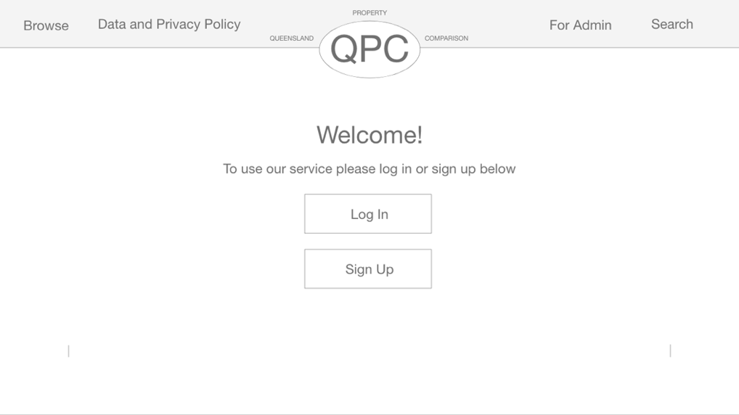

**Initial Screen**

* Users are greeted by this screen where they are directed to sign up or log in
* Log in and sign up buttons will then direct users to their respective pages, shown below

**Sign Up Screen**

* Users are directed to enter their information to sign up
* While this wireframe doesn’t show it, the ‘Name of business’ box will be hidden until users select the ‘Yes’ button, that indicates they work in real estate, as users who don’t work in real estate do not need to enter the name of their business
* Users information, once passed the verification checks, will then be entered into a database of users
* Finally, users will be directed to log in using their newly created user account. Whilst this is not the most effective solution, this style has been used due to the personal constraints identified above

**Log in Screen**

* Users are directed to enter their username and password.
* NOTE: the user’s email will be their username, and this will be more clearly communicated in the final solution
* Forgot password option will send an email to users directing them how to reset their password (will not be completed within the final solution to do personal constraints

**Initial Search Screen**

* After logging in users will be redirected to this screen and prompted to select a suburb by searching or using the dropdown menu
* On this screen, selecting any of the buttons on the navigational bar will direct users back to this same screen, as it is a requirement to sign in before using the web application’s service.
* Verification of the input from the user occurs when they log in, ensuring users are entering the correct information.

Requirements include:

* + Minimum of one character in the first name, last name and occupation boxes
  + A proper email, as specified by the ‘email field’ in the form this means it requires users to use an ‘@’ symbol, then at least one character, followed by ‘.com’.
  + Passwords entered must be the same and must have a minimum of 6 characters, ensuring complexity and reducing the risk of hacking into users accounts.
* NOTE: ‘Log in’ and ‘Sign up’ buttons within the navigational bar will be removed within the final solution, as users must log in or sign up before using the service. Potentially they will be replaced by a search button - see the initial screens navigational bar
* Users who accidentally select Log in instead of Sign up have the option to redirect themselves back to the Sign Up screen, adding a safety element
* On this screen, the buttons in the navigation bar at the will work, allow users to easily redirect around the webpage
* NOTE: The admin page will only be accessible by admin users.

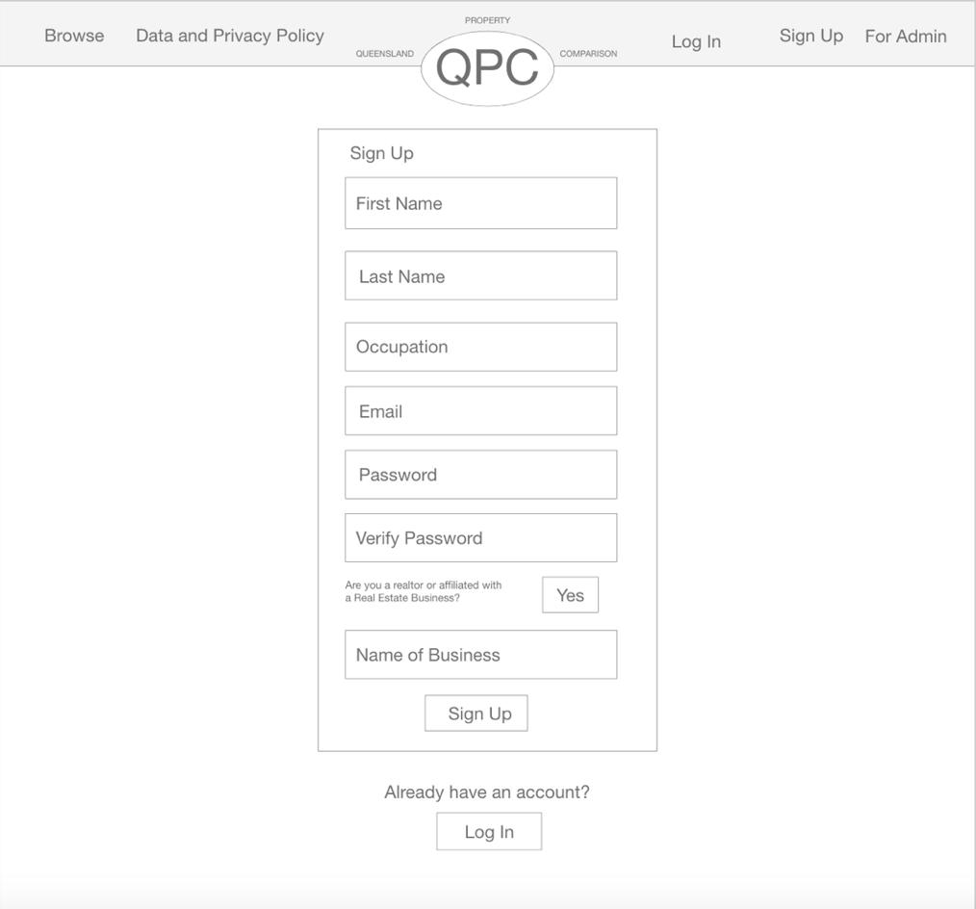

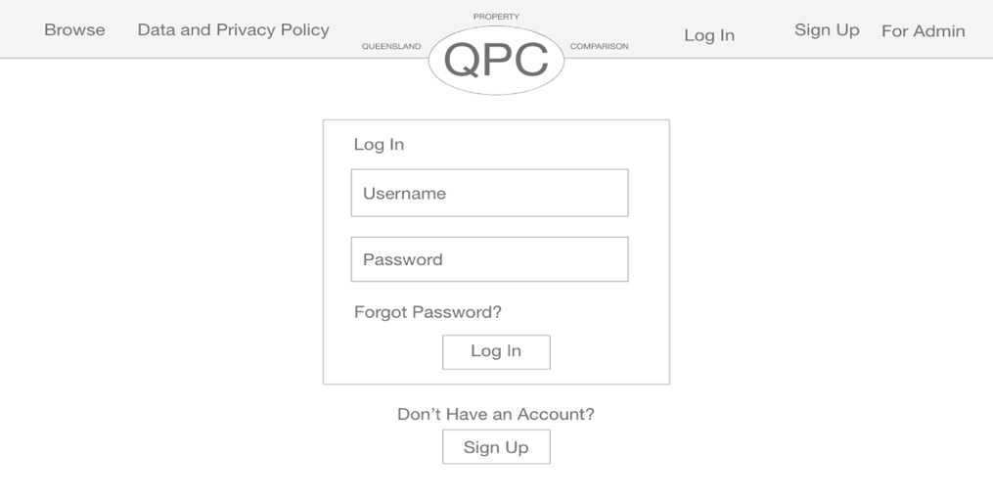

Search

* Users select their preferred distance to a school and a bus stop from the drop down menus, which will give options like 100m, 500m, 1km, and 2km.
* The users search selections will still stay at the top of the screen, ensuring they know what they searched, and giving them the opportunity to change it

**Searching With Filters**

* The initial design was to have two pages to search, but this was changed to improve efficiency, combining the pages into one.

**Search Results Page**

* Once users press the search button on the screen above, the web application will search through the ‘Properties’ table and bring up the houses that match their requirements
* Properties will be organised in cards, displaying:
  + Image/s of the property
  + Address
  + Status (for sale, for rent)
  + Bedroom number
  + Bathroom number
  + Garage number/car spaces
  + A description of schools and transport options near the house, including the distance to the house

**Browse Page**

* This page gives users the option to scroll through available properties and explore the Queensland market without having to decide on a specific suburb
* Users can access this page using the browse button within the navigational bar

Search

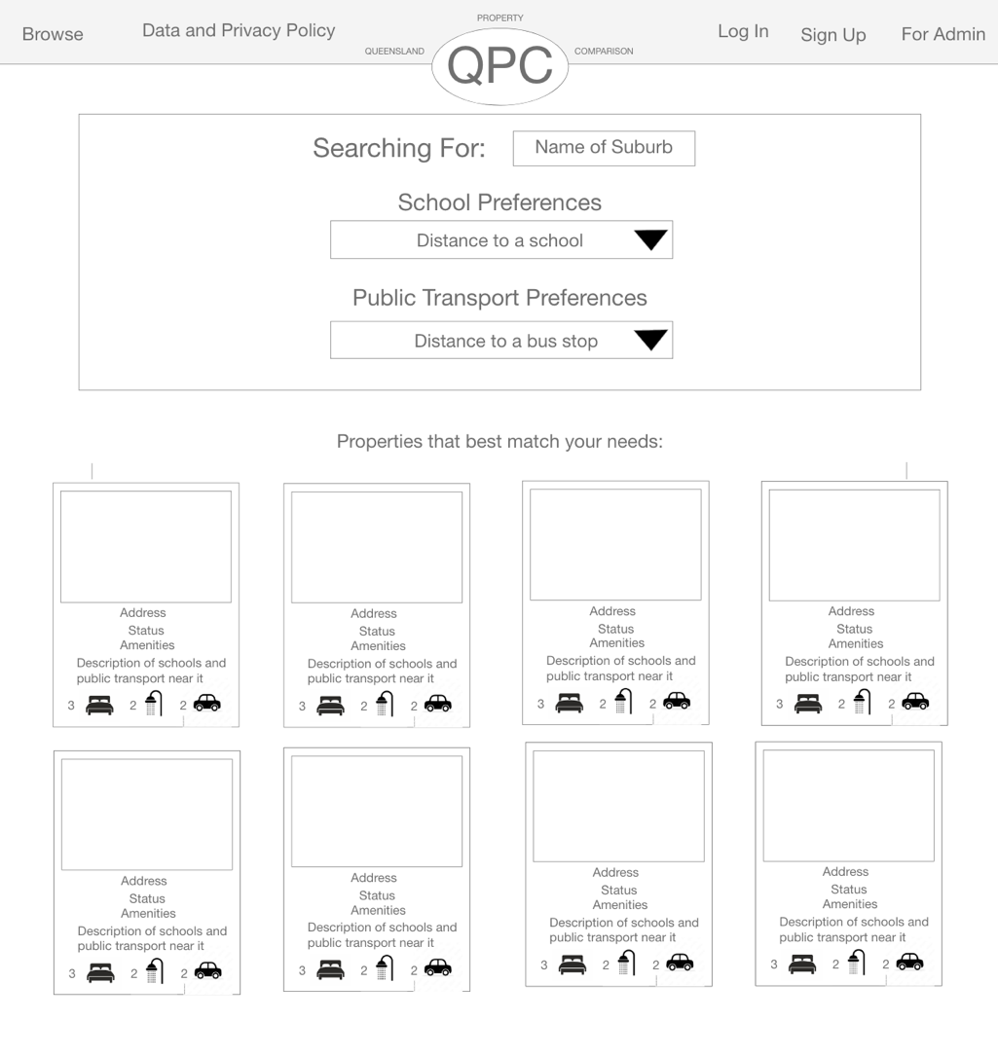

**‘**

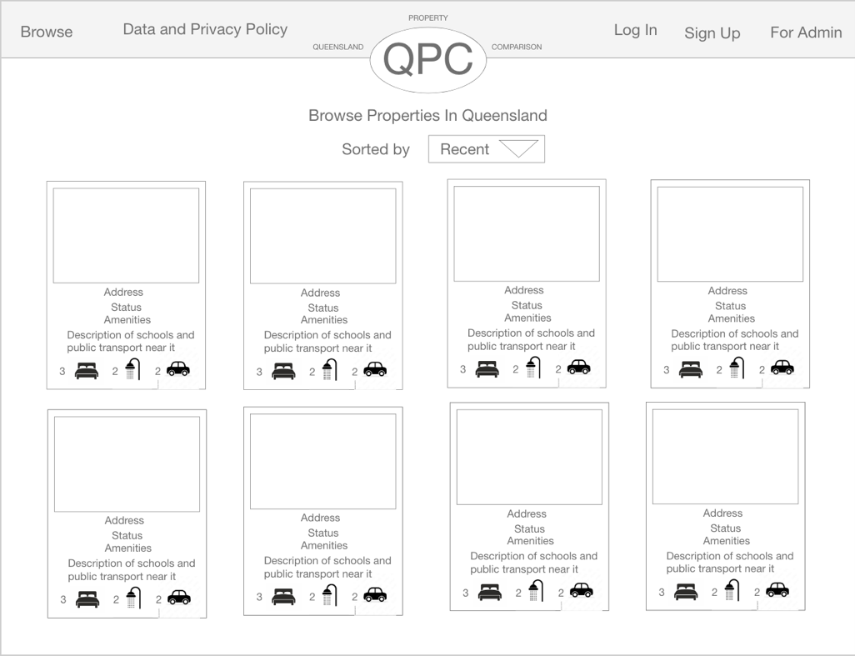

**NOT DEVELOPED:**

* Data and Privacy Policy Page -> Accessible by a button in the navigational bar. This page will describe how the data works and how it is used throughout the web application. It has no coded components and was therefore not developed.
* For Admin Page -> Accessible by a button in the navigational bar, but only shown to admin users. This page will allow users to upload data to the web application, as it is almost guaranteed that the database of schools and buses currently in use will need to be updated in future years. However at the time of development of these wireframes, the design of the page was undecided on so it was not developed in the primary stages of design.

**Data**

**Data Dictionary**

This data dictionary displays the data entities within the application. Users, Properties, Bus_Stops and Schools. Each has a unique key and follows Second Normal Form. The Entities have no foreign keys and instead are joined in the application. For example finding schools within a user defined distance of a property by comparing the lat long of the property and the school. Third normal form, for example extracting suburb, was not consider required for the scale of this application.

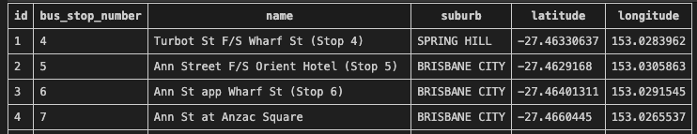Bus Stops Table

|  |  |  |  |  |
| --- | --- | --- | --- | --- |
| Field Name | Data Type | Description | Field Size | Example |
| id | Integer | Primary key | 8 bytes | 10 |
| bus_stop_number | Integer | Bus stop number | 8 bytes | 1234 |
| name | Integer | Name of the bus stop | 8 bytes | Bus stop A |
| Suburb | Text | Brisbane suburb | 255 char | Brisbane City |
| Latitude | Integer | Measure distance north or south of equator | 8 bytes | -27.4633001 |
| Longitude | Integer | measures distance east or west of the prime meridian | 8 bytes | 153.021212 |

School Table

|  |  |  |  |  |
| --- | --- | --- | --- | --- |
| Field Name | Data Type | Description | Field Size | Example |
| id | Integer | Primary key | 8 bytes | 10 |
| name | Integer | Name of the school | 255 char | Clayfield College |
| Suburb | Text | Brisbane suburb | 255 char | Brisbane City |
| Latitude | Integer | Measure distance north or south of equator | 8 bytes | -27.4633001 |
| Longitude | Integer | measures distance east or west of the prime meridian | 8 bytes | 153.021212 |

Properties

|  |  |  |  |  |
| --- | --- | --- | --- | --- |
| Field Name | Data Type | Description | Field Size | Example |
| id | Integer | Primary key | 8 bytes | 10 |
| address1 | Integer | Address line 1 | 255 char | 12 |
| adddress2 | Text | Address line 2 | 255 char | 132 main st |
| suburb | Text | Brisbane suburb | 255 char | Brisbane City |
| postcode | Text | Australian PostCode | 255 char | 4000 |
| state | Text | Australian State Code | 255 char | QLD |
| Image | Text | Reference to property image | 255 char | House.png |
| lat | Integer | Measure distance north or south of equator | 8 bytes | -27.4633001 |
| long | Integer | measures distance east or west of the prime meridian | 8 bytes | 153.021212 |
| description | Text | Blurb advertising the house | 255 char | Nice house… |
| Price | Integer | Advertised price for sale | 8 bytes | 400000 |
| type | Text | Type of building | 255 char | House |
| age | Integer | Age in years | 8 bytes | 10 |
| bedrooms | Integer | # bedrooms | 8 bytes | 3 |
| bathrooms | Integer | # bathrooms | 8 bytes | 2 |
| carspaces | Integer | # car spaces | 8 bytes | 2 |
| housearea | Integer | House area in meter squared | 8 bytes | 600 |

Users

|  |  |  |  |  |
| --- | --- | --- | --- | --- |
| Field Name | Data Type | Description | Field Size | Example |
| id | Integer | Primary key | 8 bytes | 10 |
| first_name | Text | User first name | 255 char | Jane |
| last_name | Text | User second name | 255 char | Williams |
| occupation | Text | Occupation of the user | 255 char | Agent |
| Email | Text | Email and username of the user | 255 char | [me@now.com](mailto:me@now.com) |
| password | Text | Hash of the user password | 255 char | …. |
| Businessname | Text | Business if in realestate | 255 char | my RealEstate |
| Is_admin | Boolean | True if admin, default False | 1 byte | 0 |

**Data Flow Diagram (DFD)**

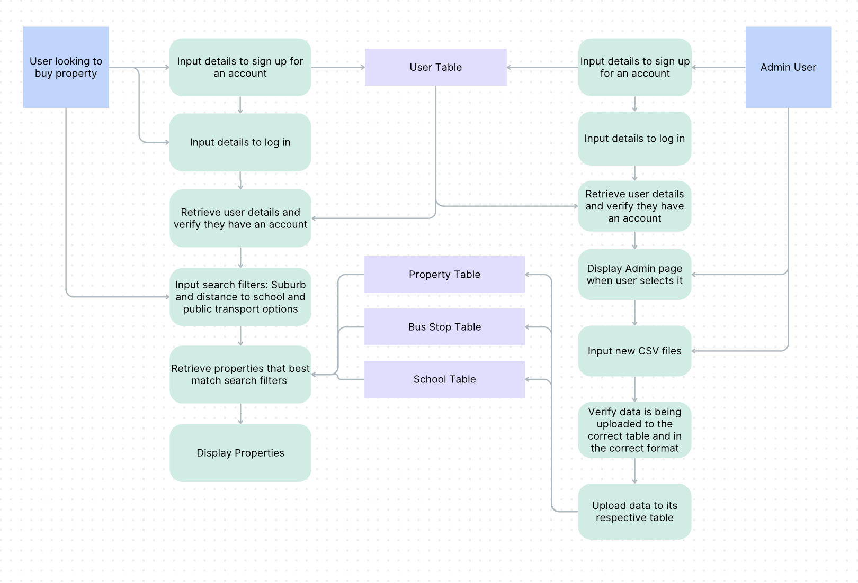

This data flow diagram demonstrates the flow of data from the perspective of a user looking to buy property and use the search feature, and an admin user trying to update the databases with new CSV files. It was created on canva.

It depicts the interrelationships between the users experience and the data, as well as between the data and the elements of the coded solution.

Squares represent external entities (type of user), rectangles represent data stores (tables within the overall database) and rounded rectangles represent system processes.

**Coded Components Described in the DFD Communicated in Pseudocode**

**Verification of User’s Data**

Begin

INPUT User data -> First Name, last name, occupation etc.

VERIFY Data against requirements:

First Name: Stringfield, Min 1 character, Max 10 characters

Last Name: Stringfield, Min 1 character, Max 10 characters

Occupation: Stringfield, Min 1 character, Max 20 characters

Email: Emailfield (requires an @ symbol and a ‘.com’), Min 1 character, Max 10 characters

Password: Passwordfield, Min 6 characters, Max 25 characters

Verify Password: Passwordfield, Min 6 characters, Max 25 characters, must match Password input

In real estate question: Yes or No

If ‘In real estate question’ is ‘Yes’:

Business name: Stringfield, Min 1 character, Max 20 characters

Else:

Business name: Empty

End

**Logging In**

Begin

INPUT User data -> Email, Password

RECALL users Table from QPC Database

SEARCH for Email that equals Users email

If Email exists:

FIND Password in row where Email equals Users email

If Password matches User Unput:

Log in User

Else:

DISPLAY: Your Email or Password is incorrect, please try again.

Else:

DISPLAY: Your Email or Password is incorrect, please try again.

End

**Uploading Schools CSV Files to Update Database**

Begin

INPUT User Data -> File

IF Data is a CSV File:

If Headings are: Header 0 = ‘_id’, Header 2 = ‘Centre Name’, Header 18 = ‘Actual Address Line 3’, Header 38 = ‘Latitude’, and Header 37 = ‘Longitude’:

DELETE Current schools table content

INSERT Data into correct columns by matching the header name

DISPLAY: ‘Data has been updated’

Else:

DISPLAY: ‘Data is not in the correct format, please check your headings and try again’

Else:

DISPLAY: Data is not the correct file type, please try again

End

**Search Function**

Begin

INPUT User Data -> Suburb, Distance to Schools, Distance to Bus Stops

RECALL properties Table from QPC Database

FIND properties where suburb = selected suburb

DISPLAY: Image, Name, Address, Description, Bedroom Number, Bathroom Number, Car Space Number, Size

RECALL schools Table from QPC Database

RECALL bus_stops Table from QPC Database

For all properties where suburb = selected suburb:

For all schools:

If selected distance to schools > distance between school and property

DISPLAY School

Else:

Do not DISPLAY

For all bus stops

If selected distance to bus stops > distance between bus stop and property

DISPLAY Bus stop

Else:

Do not DISPLAY

End

**Evaluation**

**Investigating Criteria**

This table contains the prescribed and self-determined criteria and uses a colour system to show the extent of completion – Red = Not completed, Orange = Partially completed, and Green = Fully Completed.

|  |  |  |
| --- | --- | --- |
| **Criteria** | **Completion** | **Discussion** |
| Allows exploration and comparison of the property market using school locations and transportation services criteria data. |  | Evident in the search function - after selecting their requirements, users can compare resultant properties by looking at the schools and bus stops near each property, contained within the property card. |
| Allow users to search for properties based on these criteria (schools and transportation) by entering a keyword |  | Evident in the search function – users select a suburb then their preferred distance to schools and bus-stops (the keywords). |
| Contains an information page that provides appropriate explanations of the data, definitions of terms, the source of the data and how the data is used. |  | Evident in the data policy page. |
| Provide an administrative tool that allows editing and updating of the database set – specifically allowing upload of the transport and school information to the website from a .csv file. |  | Evident in the admin page, which provides users a platform to upload .csv files specifically containing bus-stops and school information. As shown in the code, the page also ensures that only bus-stop data is uploaded within the bus stop section, and the same for schools, by checking the file has the correct headings that match the database. |
| Allow users to register the following personal details with the site: First name, last name, occupation and name of real estate agency/business |  | Evident when users must log in before gaining access to the sites features – including the search function and browse. When logging in they must enter their first name, last name, occupation, and email, shown to the user with the red asterix next to these fields, which is communicated at the bottom of the page as meaning ‘required field’. Then, they are asked to check a box if they work in real estate, and if they do, another field appears, asking them to enter their business name. This ensures the site records the name of their real estate agency, while also being accessible to users who do not work in real estate. |
| Provides an intuitive, responsive and dynamic web interface |  | Bootstrap style ensures the website is responsive, allowing it to be used across various sized technology including phones, laptops, tablets ecetera. |
| Apply accessibility and usability principles |  |  |
| Include appropriate attribution to data and images used |  | Appropriate attribution to data and images used can be found within the data policy page. |
| Comply with copyright law |  | Achieved with the copyright footer at the bottom of each page and the correct attribution to data and images used within the data policy page. |
| The web application complies with Government web design standards, specifically their accessibility requirements |  |  |
| The web application complies with the Australian Privacy Act (1988) |  | DATA POLICY - don’t give information away and only collect whats necessary – tell you what were using it for (NEEDS LAYWER REVIEW)  Doesn’t have the ability to delete yourself |
| Read records from a csv file and store them in a database table |  | The files importbusstops.py and importproperties.py use SQL programming to create the tables bus_stops and schools, and then insert the initial data into its respective table. |
| Search the database based on specified criteria and display the results |  | Evident in the search function – users create their specific criteria by selecting a suburb from a drop down list, then selecting a distance to schools and distance to bus-stops again from a drop down list. The properties that match this search are then displayed in cards. |
| Record and validate user registration details |  | The webpage validates users personal data when they sign up, ensuring it passes checks such as a required amount of characters, a valid email address by checking the format (use of an @ symbol), that required fields are filled in, that the ‘password’ and verify password’ fields match, ectera. |
| Ensure the site is being operated by an authenticated user |  | The webpage classifies an authenticated user as someone logged in. To log in, if they haven’t already, users must sign up, then log in, then they will have full access to the site. If they are not authenticated and try to navigate to the browse or search page an error message will display, prompting them to sign in. However users will be able to access the data policy before they log in, allowing them to read about how their data is used before they choose to sign up |
| Utilise a “session” variable to manage the user’s “login” information |  | loginmanager |
| An algorithm for checking the csv data before loading it into the database. |  | When the initial data is uploaded into the database using the files importbusstops.py and importproperties.py, it is checked using the requirements specified in the SQL algorithms within these files. These requirements are the type of data it is, for example TEXT and INTEGER, which determine what type of characters are allowed in a specific column.  However this was simply just to load some data onto the site when building it. In reality all data should be loaded onto the site using the admin feature, which has an extensive algorithm for checking the data, data by verifying that the table has the correct headings, therefor ensuring that the data isn’t missing elements such as a column in the table. If it is missing an essential column, or the heading names no not match the specified headings, an error message will appear. |
| Appropriate validation checks on new data before it can be uploaded to the database |  | When administrators attempt to upload data using the admin feature, the webpage validates that the csv file is the correct data by verifying that the table has the correct headings, and therefor ensures that the data isn’t missing elements such as a column in the table. If it is missing an essential column, or the heading names no not match the specified headings, an error message will appear. |
| An incorrect user registration will not be stored in the database |  | If users enter an incorrect registration, such as an invalid email, not enough characters in a password, ect. the site will not store it in the database, instead providing a relevant message, prompting the user to fix the issue they made. |
| Contains a browse function/page for users who want to see what is available to them, without having to search for a specific suburb |  | Evident within the browse page, which displays all the properties within the properties database, in cards, allowing users to scroll throw and explore what is available. While this criteria is achieved, this page does not show schools or bus stops that are close by. |
| Use the design principles of  balance, contrast, proximity, harmony, alignment, repetition and hierarchy to create a visually appealing website that ensures users enjoy using the web application and invites them to continue to use the service |  | Balance: Completed – evident in the symmetrical spacing of the property cards, 3 properties take up every row.  Alignment: Completed – properties are aligned horizonantally and vertically, and all take up the exact same amount of space. Also, the all elements in the top navigational bar are aligned horizontally.  Contrast: Completed - Majority of the text is in a black colour with a white background, providing sufficient contrast for users to easily read it. Additionally, any other text is in a bright blue colour, which also has enough contrast with the white background.  Repetition: Completed – The same font is used throughout the website, and the properties are displayed in the same format within cards with the image at the top and the information below.  Proximity: Completed: Cards containing properties have exactly the same amount of sufficient padding (space) between them. Also suitable padding exists between fields requesting users details when they sign up. |
| Use the REIQ colour pallet to ensure a cohesive blend between the two pages and to utilise the design principle of repetition |  | This criteria was not achieved due to time constraints. The web application does have a colour pallet of green and blue, showing cohesion and the use of the design principle repetition, for example, all buttons are the same blue colour, however this is not the REIQ colour pallet of red and orange. |
| Addresses identified user needs using the potential user profiles. |  |  |

**Potential Impacts of the Solution**

|  |  |  |
| --- | --- | --- |
| Personal | Social | Economic |
| * Improve individual buyer’s ability to find houses that match their needs | * Provide another tool for real estate businesses to advertise and sell properties on, potentially increasing their sales | * Help generate more income for real estate agents by providing another platform to advertise houses on |
| * Provide another platform for realtors to investigate properties on the market, and develop a greater understanding of the areas they work in and the market they sell in | * Provide another website that rural communities or can use to spread awareness about properties for sale in their area, as many people may miss the physical ‘For Sale’ signs on the houses due to their locations | * As seen above, potentially increase the sales of homes by providing another platform for buyers to find available houses. This may affect the home buying market and the home buying economy |
| * Help homeowners sell their homes by providing another platform to find sales on |  |  |
| * Educate individuals on how data is stored and used on property comparison websites, potentially increasing their general knowledge about the backend of websites and data |  |  |

**Recommendations**

- An interface that has applied usability principles https://www.interaction-

design.org/literature/topics/usability and https://www.desi gnprinciplesftw.com/collections/10-

usability-heuristics-for-user-interface-design

- Adherence to Web Content Accessibility Guidelines. Refer

https://www.w3.org/WAI/standardsguidelines/wcag/glance/

**References**

<https://www.propertyvalue.com.au>

<https://www.property.com.au>

Feedback from last year

* when presenting algorithms in pseudocode, ensure that you demonstrate a comprehensive understanding of programming features. Clarify your logic and consider providing additional explanations or examples to support your code
* pay attention to the interrelationships between user experiences and programming in the prototype interactive learning object. Clearly articulate how user interface components and programming elements are interconnected, utilizing annotated diagrams to strengthen your explanations.

Strengths

* your ability to recognize and describe programmed and user-interface components was commendable. Your understanding of the different components and their roles within the web application showcased your knowledge of digital solutions
* the usability principles, including accessibility, effectiveness, safety, utility, and learnability, were effectively incorporated into your web application. You showcased a strong awareness of the user's needs and implemented design elements that enhanced the overall user experience.